1. Passengers and Cabin Baggage - LIST OF PROHIBITED ARTICLES - Regulation (EU) 2015/1998, Attachment 4-C
Without prejudice to applicable safety rules, passengers are not permitted to carry the following articles into security
restricted areas and on board an aircraft.

- a.) Guns, firearms and other devices that discharge projectiles – devices capable, or appearing capable, of being used to cause serious injury by discharging a projectile, including:

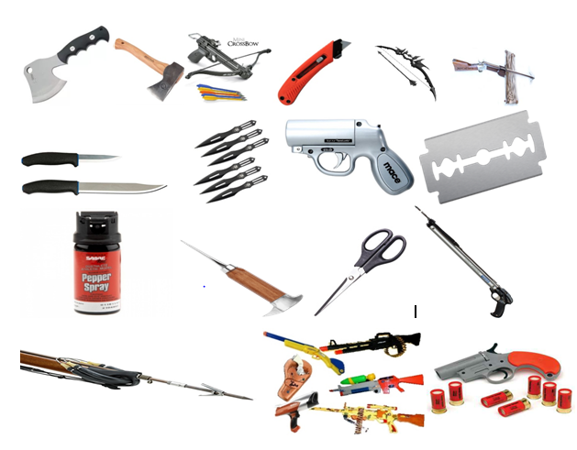
Pistols, revolvers, rifles, shotguns, toy guns and replicas capable of being mistaken for real weapons Compressed air and CO2 guns, Pellet guns, component parts of fire arms, cross bows and arrows Signal flare and starter pistols, harpoon and spear guns slingshots and catapults
b.) Stunning devices – devices designed specifically to stun or immobilize, including:
Stun guns, stun batons, mace, tear gas, tasers
Other disabling and incapacitating gases and sprays
like animal repellent, capsicum and acid sprays
Animal stunners and animal killers

- c.) Objects with a sharp point or sharp edge, capable of being used
- to cause serious injury

Ice picks and axes, knives with blades of more than 6 cm
Razor blades, Martial arts equipment, Swords and sabres, box cutters, hatchets, bolt and nail guns, Cleavers, Scissors with blades of
more than 6 cm as measured from the fulcrum,
d.) Workmen's tools-tools capable | apable of being used either to cause serious
Injury or to threaten the safety of aircraft, including:

Crowbars, Drills and Saws including cordless portable power tools
Blowtorches, tools with a blade or shaft of more than 6 cm
e.) Blunt instruments - objects capable of being used to cause injury when used to hit, including:
Baseball and softball bats, Clubs and batons, billy clubs, blackjacks, Night sticks, Martial arts equipment
f.) Explosives and incendiary substances and devices capable, or appearing capable, of being used to cause
serious injury or to pose a threat to the safety of aircraft, including:

Ammunition, Blasting caps, detonators and fuses, replica or imitation explosive devices,
Mines, grenades and other explosive military stores, Fireworks and other pyrotechnics
Smoke-generating canisters and smoke-generating cartridges, Dynamite, gunpowder and plastic explosives.

2. Hold Baggage - LIST OF PROHIBITED ARTICLES - Regulation (EU) 2015/1998, Attachment 5-B
Passengers are not permitted to carry the following articles in their hold baggage:
Explosives and incendiary substances and devices capable of being used to cause serious injury or to pose a threat to
the safety of aircrafts, including:

Ammunition, blasting caps, detonators and fuses, mines, grenades and other military explosives Fireworks and pyrotechnics smoke-generating canisters and smoke-generating cartridges Dynamite gunpowder,
and plastic explosives.

ATTACHMENT 5-B: HOLD BAGGAGE - LIST OF PROHIBITED ARTICLES
Passengers are not permitted to carry the following articles in their hold baggage:
f. Explosives and incendiary substances and devices – explosives and incendiary substances and devices capable of being used to cause serious injury or to pose a threat to the safety of aircraft, including:
- Ammunition.
- Blasting caps.
- Detonators and fuses.
- Mines, grenades, and other explosive military stores.
- Fireworks and other pyrotechnics.
- Smoke-generating canisters and smoke-generating cartridges.
- Dynamite, gunpowder and plastic explosives.

ATTACHMENT 4-2: LIST OF PROHIBITED ARTICLES (CABIN BAGGAGE)
Passengers are not permitted to carry the following articles into security restricted areas and on board an aircraft:
a. Guns, firearms and other devices that discharge projectiles – devices capable, or appearing capable, of being used to cause serious injury by discharging a projectile, including:
- Firearms of all types, such as pistols, revolvers, rifles, and shotguns.
- Toy guns, replicas, and imitation firearms capable of being mistaken for real weapons.
- Component parts of firearms, excluding telescopic sights.
- Compressed air and carbon dioxide guns, such as pistols, pellet guns, rifles, and ball bearing guns.
- Signal flare pistols and starter pistols.
- Bows, cross bows, and arrows.
- Harpoon guns and spear guns.
- Slingshots and catapults.
b. Stunning devices – devices designed specifically to stun or immobilise, including:
- Devices for shocking, such as stun guns, Tasers, and stun batons.
- Animal stunners and animal killers.
- Disabling and incapacitating chemicals, gases, and sprays, such as mace, pepper sprays, capsicum sprays, tear gas, acid sprays and animal repellent sprays.
c. Objects with a sharp point or sharp edge – objects with a sharp point or sharp edge capable of being used to cause serious injury, including:
- Items designed for chopping, such as axes, hatchets and cleavers.
- Ice axes and ice picks.
- Razor blades; - Box cutters.
- Knives with blades of more than 6cm.
- Scissors with blades of more than 6cm as measured from the fulcrum.
- Martial arts equipment with a sharp point or sharp edge.
- Swords and sabres.
d. Workmen’s tools – tools capable of being used either to cause serious injury or to threaten the safety of aircraft, including:
- Crowbars.
- Drills and drill bits, including cordless portable power drills.
- Tools with a blade or a shaft of more than 6cm capable of use as a weapon, such as screwdrivers and chisels.
- Saws, including cordless portable power saws.
- Blowtorches.
- Bolt guns and nail guns.
e. Blunt instruments – objects capable of being used to cause serious injury when used to hit, including:
- Baseball and softball bats.
- Clubs and batons, such as billy clubs, blackjacks and night sticks.
- Martial arts equipment.
f. Explosives and incendiary substances and devices – explosives and incendiary substances and devices capable, or appearing capable, of being used to cause serious injury or to pose a threat to the safety of aircraft, including:
- Ammunition; - Blasting caps.
- Detonators and fuses.
- Replica or imitation explosive devices.
- Mines, grenades, and other explosive military stores.
- Fireworks and other pyrotechnics.
- Smoke-generating canisters and smoke-generating cartridges.
- Dynamite, gunpowder, and plastic explosives.

